Name: Brianna Beverley
Date: 2/8/11
TV Studio – Matching Activity

Please label each piece and what it does.
This is a video camera. You can record videos. This is a computer hard drive.
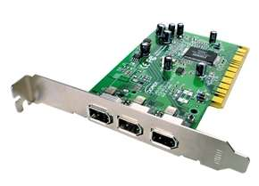
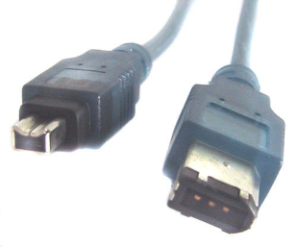
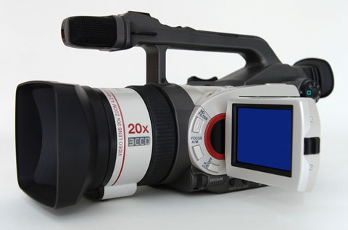

This is a firewire cable.
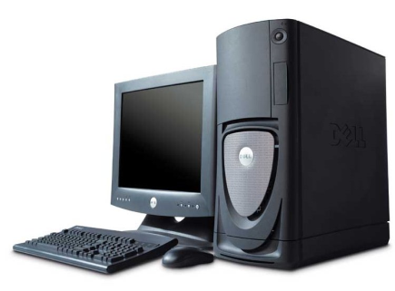
It is used to connect a video camera to the hard drive of a computer and record live video.

This is a computer. It is used for multiple items, such as browsing the internet, recording and making movies, doing work, etc.

